Case Study: Leading Across Cultures – Effective Team Management at EcoBright Solutions (Malaysia)

Background
EcoBright Solutions, a mid-sized renewable energy company based in Kuala Lumpur, Malaysia, had grown rapidly since its establishment in 2015. With a vision to lead sustainable innovation in Southeast Asia, EcoBright expanded its workforce to over 250 employees across three regional offices by 2024.
As the company expanded, managing diverse, multi-ethnic teams became increasingly complex. Malaysia’s multicultural environment – comprising Malays (around 69% of the population), Chinese (23%), Indians (7%), and other ethnicities (1%) – brought both richness and challenges to team management at EcoBright.

The Challenge
By late 2024, the management team began noticing performance inconsistencies across regions:
- Kuala Lumpur HQ: Teams consistently met 95% of project deadlines.
- Penang Office: Team productivity was at 85% with frequent internal conflicts.
- Johor Bahru Office: Delivered only 78% of projects on time, with growing turnover rates (up 15% compared to the previous year).
An internal survey revealed key concerns:
Survey Area | Satisfaction Score (out of 5)
Leadership Communication | 3.2
Team Collaboration | 3.0
Work-Life Balance | 4.1
Recognition & Rewards | 2.8
Professional Growth | 3.5
Employees cited unclear communication from managers, cultural misunderstandings, and perceived favoritism as major demotivators. Younger employees (below 30) also expressed a desire for more inclusive decision-making.

New Strategy Implementation
In early 2025, CEO Lim Wei Jun initiated the "One Voice, One Team" project aimed at revamping the team management approach across all offices. Key actions included:
- Cross-Cultural Management Training:
100% of team leads attended workshops on managing multicultural teams, unconscious bias, and active listening techniques.
- Monthly Townhall Meetings:
Open forums were set up, where employees could voice concerns directly to leadership.
- Revamped Recognition Program:
A points-based system rewarded not just results but also collaboration, creativity, and mentorship efforts.
- Structured Goal-Setting with KPIs:
Each department adopted a transparent KPI system aligned with company-wide objectives, emphasizing shared responsibility.
- Buddy Program for New Joiners:
Every new employee was paired with a "buddy" from a different ethnic background to foster early integration.
- Local Empowerment with Global Standards:
Regional offices were given autonomy to adapt strategies locally, while adhering to EcoBright’s core leadership principles.
The new model also emphasized "High-Context" communication – a style more natural in Asian cultures, focusing on indirect cues, relationships, and consensus rather than Western-style directness.

Outcomes (Six Months Later)
After six months, EcoBright conducted another round of evaluations:
- Project Completion Rates:
  - Kuala Lumpur HQ: 96% (up 1%)
  - Penang Office: 91% (up 6%)
  - Johor Bahru Office: 88% (up 10%)
- Employee Turnover:
  - Decreased by 8% company-wide.
- Engagement Scores:
  - Leadership Communication: Improved from 3.2 to 4.0.
  - Team Collaboration: Improved from 3.0 to 4.2.
  - Recognition & Rewards: Improved from 2.8 to 3.9
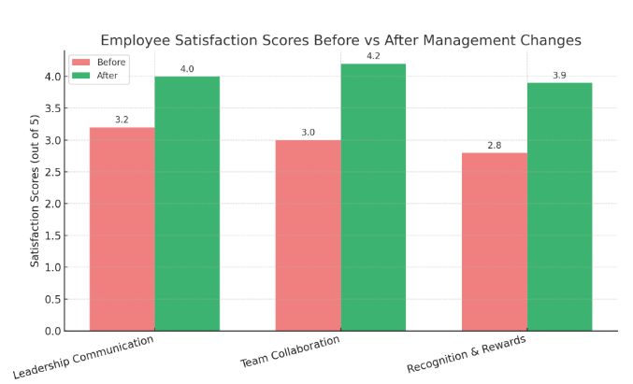

Question to Solve:
As a consultant for EcoBright Solutions, how would you justify the management changes?

